INTELLIGENT CARGO MANAGEMENT SYSTEM USING

INTERNET OF THINGS

**Problem Statement : 21**

**TEAM ASGARDIANS**

**B.Madhava Reddy**

**K.Yeswanth**

**G.Jaswanth**

INTELLIGENT CARGO MANAGEMENT SYSTEM USING

INTERNET OF THINGS

Abstract:

In Supply Chain Management the transportation of perishable agricultural products effectively plays a vital role in the sustainability of the entire process.It is also to be noted that most of the post- harvest wastage occurs in the transportationphase.

In this project we propose a system to optimize the transportation of the perishable products. Allow Wireless Sensor Network using HC 05 bluetooth module which is used to monitor the physical and environmental conditions like temperature,humidity and Air Quality thereby enabling these low power devices to be a part of the Internet of Things (IoT).

The past learning experiences of the freightare incorporated to make appropriate decisions in order to enhance the profits earned by the supplier and also to satisfy the demands of the consumer by supplying the perishable products at the correct scale of freshness.

Introduction:

The idea of IoT is that everything can be tracked and traced remotely. The concept of IoT is to make the machines and computers independent of people and try interpreting and manipulating data. The world comprises of many devices that are connected to each other.There is a necessity for these devices to be connected to each other. This service is provided by the bluetooth. All information from the devices is exchanged via the bluetooth.

The IoT is used in various fields which include IT, e-business, logistics and so on. It is also applicable in urban planning, healthcare, waste management, security and in monitoring traffic. If all objects and people in daily life were equipped with identifiers, they could be managed and inventoried by computers.From a conceptual standpoint, the IoT builds on three pillars, related to the ability of smart objects to:

1. be identifiable (anything identifies itself),
2. to communicate (anything communicates) and
3. to interact (anything interacts)– either among themselves, building networks of interconnected objects, or with end-users or other entities in the network.

II. BACKGROUND &RELATED:

Work Tracing the food products during transportation is of prime importance.Tracing can be done in two ways namely active and passive. The passive tracing method actually focusses on the position of the object at all times and disposition from that place. The information stated is that active tracing method keeps track of the online information in order to optimize and control process between the various phases of the supply chain. There are three basic objectives of tracing a product they are improving the supply chain management, differentiate between the products using quality as a measure and to provide functions to estimate the safety and quality of the product.

Tracking the individual product and the distribution unit plays a major role in determining the efficiency of the traceability process. The physical traceability focuses on the actual tracking of the product whereas the qualitative traceability involves tracking the quality of the product. The food chain would require the key aspects of traceability to prevail.

In the system architecture of Internet of things (IoT) system four layers are present: object sensing layer, data exchange layer, information integration layer, and application service layer. The object sensing layer is concerned with sensing the objects and obtaining data. The data exchange layer handles an efficient and secure transmission of object data.

Environmental impact can be regarded as a product quality dimension which however is not visible throughout the supply chain process. Bluetooth can be used as a medium to exchange information between the various actors participating in the supply chain process to improve transparency and thereby to support sustainability.

III. PROBLEM DEFINITION AND MOTIVATION:

Supply Chain Management consists of a number of phases in which the transportation plays an important role. The perishable products are to be delivered at the desirable quality in the right time. The problem that is addressed in this paper deals with optimal delivery of the goods either to the sub warehouse or to the shopping market. The lack of constant monitoring of the product during the freight contributes towards the food wastage during the transportation phase. The various factors that influence the freshness scale of the product which includes the natural and physical conditions are to be considered before the movement of the goods from the source to the destination. The collected data needs to be processed efficiently to make the right decisions.

IV. PROPOSED SYSTEM MODEL:

The system design consists of the sensors deployed inside the truck and the gateways which communicate to the monitoring centre using the Bluetooth module fixed in the cargo.

The sensors are deployed inside the truck to monitor the freshness of the product. The values read by the sensors are sent to the monitoring system using HC 05 Bluetooth Modules. Based on the values received from the gateways, the monitoring centre makes appropriate decisions to optimize the journey.

The monitoring system is present in the main warehouse and many shopping markets are connected via sub warehouses.During the freight if there is any change in the freshness level of the food product which is indicated by the sensors placed inside the truck, then the information is sent to the monitoring centre. Based on the level of freshness of the product, it will be removed or delivered to the nearest shopping market.If the freshness level falls below the scale, the product is replaced in the nearest sub warehouse.

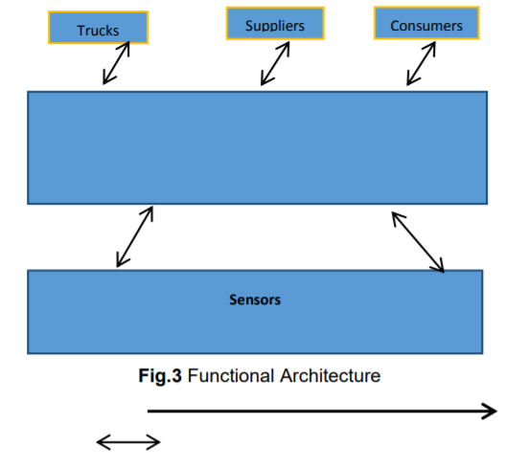

INFORMATION FLOW:

The functional architecture of the proposed system is depicted in Fig3. The layer in the bottom includes the sensors where the condition of the product is sensed at frequent intervals. The data is sent to the gateway and then to the monitoring center. The second layer in the figure denotes the operations that are carried out in the monitoring center which includes optimizing Trucks the stock, alerting the truck drivers etc. The upper layer includes the truck drivers, suppliers, users. The information is revealed at different levels to the truck drivers, suppliers and users.If there is a fall in the freshness levels the change in freight will be intimated to the truck driver. The consumers will be provided with the freshness scale of the product.

V. IMPLEMENTATION DETAILS

A. Optimization of freight:

The driver is provided with the optimized freight route depending on the current climatic conditions and also the past experience is taken into account.The sensors deployed in the truck will monitor the condition of the product and the values are sent to the monitoring center at regular intervals. When the values read fall below the specified levels, the truck is provided with the new route to the nearest warehouse in order to deliver the products at the nearby markets or to remove the decayed products from the truck so that the entire stock is not subjected to further decay.

B. Sensor Information:

We have used a DHT 11 sensor and an MQ6 sensor

DHT 11 sensor is used to monitor the temperature and humidity levels in the cargo truck and the MQ6 sensor is used to monitor the Air Quality of the cargo and accordingly send these values to the Mobile app used by aurthorised personel using a HC 05 bluetooth module.

We also used a Node MCU board to mount all the sensors together and have a power supply to all these sensors.

.

VII. CONCLUSION:

In this project we have implemented an intelligent cargo system for efficient transportation of goods from a given source to destination. The sensors are mount on Node MCU board and the sensor values are transferred to mobile app through Bluetooth module.. Real time sensor data could be obtained using various routing protocols over the wireless medium(Bluetooth) to monitor the freshness levels and air quality by monitoring the temperature and Humidity of the cargo van,which can prevent wastage of food or reduce the scale of wastage of food.